The observation matrix is obtained by the partial derivative of the measurement function, so the determination of measurement function is the key.

The measurement function of RD-EKF is determined by radius-directed idea (The detailed description of radius-directed idea is introduced in the article, as shown in the figure2).

When the nearest radius is determined by RD idea. We can form the measurement function (64QAM):

 (X1)

The conventional measurement function of EKF (64QAM) is:

(X2)

The measurement residuals are gotten by measurement function:

 (X3)

 is the target value of measurement function.

The measurement residuals are used to update the state vector by equation:

 (X4)

Observation matrix H is obtained by the partial derivative of the measurement function.

 (X5)

The state vectors are: 

Here we use  as an example to show process of getting the observation matrix H,

We assume the received signals within the sliding window are:



The subscript t refers to the time domain signal.

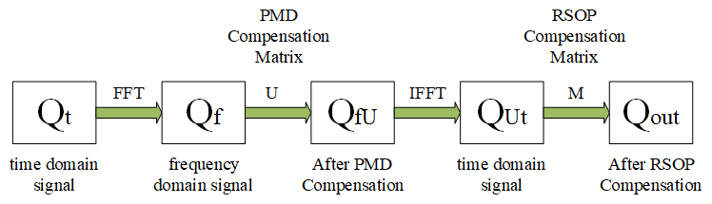

Because the PMD compensation matrix is in frequency domain, the signal needs to be transformed into frequency domain by FFT.

However, the RSOP compensation matrix is in time domain, the signal after PMD compensation needs to be transformed into time domain by IFFT.

We simplify U, M as:

 (X6)

According to X5, we calculate the Jacobi matrix down below:

 (X7)

Where , (X8)

, (X9)

After getting the observation matrix H, the Kalman gain can be calculated by:

 (X10)

At last, the filter completes the states update recursively and signal is recovered during the process.

Whole process shown in the figure 1 in article.